**Software Requirements Specification**

**for**

**E-Stationery**

**Version 1.0 approved**

**Prepared by Masand Santosh**

**Karatela Shahnawaz**

**Dhankecha Prakash**

**Zalavadiya Darshan**

**<R.K. University>**

**<21/09/2022>**

**Table of Contents**

**Table of Contents ii**

**Revision History ii**

**1. Introduction 1**

1.1 Purpose 1

1.2 Document Conventions 1

1.3 Intended Audience and Reading Suggestions 1

1.4 Project Scope 1

1.5 References 1

**2. Overall Description 2**

2.1 Product Perspective 2

2.2 Product Features 2

2.3 User Classes and Characteristics 2

2.4 Operating Environment 2

2.5 Design and Implementation Constraints 2

2.6 User Documentation 2

2.7 Assumptions and Dependencies 3

**3. System Features 3**

3.1 System Feature 1 3

3.2 System Feature 2 (and so on) 4

**4. External Interface Requirements 4**

4.1 User Interfaces 4

4.2 Hardware Interfaces 4

4.3 Software Interfaces 4

4.4 Communications Interfaces 4

**5. Other Nonfunctional Requirements 5**

5.1 Performance Requirements 5

5.2 Safety Requirements 5

5.3 Security Requirements 5

5.4 Software Quality Attributes 5

**6. Other Requirements 5**

**Appendix A: Glossary 5**

**Appendix B: Analysis Models 6**

**Appendix C: Issues List 6**

**Work Done by Team**

| **Enrolment Number** | **Name** | **Work** |
| --- | --- | --- |
| 20SOEIT11024 | Zalavadiya Darshan | UI Design/PPT |
| 21ST 13012 | Dhankecha Prakash | UI Design/PPT |
| 21ST 13084 | Masand Santhosh | All Diagram/PPT |
| 21ST 13033 | Karatela Shannavaz | All Diagram/PPT |

# **Introduction**

* Nowadays because of the internet world everything has become online. Most of the applications in our phones are E-Commerce apps.
* We are also developing an E-Stationery App. Nowadays human beings are busy with their work, so they don't have time for buying small things like pens, pencils etc. things.

## **Purpose**

* The E-Stationary is an Android based Application intended to provide a complete solution to vendors as well as customers through apps using the internet. It will enable vendors to set up online Stationery shops.
* Customers Use this App when they have to go to purchase stationery items and customers don’t want to go to stationery for time saving or they don’t want to wait for their turn then customers use this app to purchase items online or book items online.

## **Document Conventions**

* + The Main Heading of this document are as follows:
* Font-Face: Times New Roman
* Font-Style: Bold
* Font-Size: 18pt
  + The Sub Heading of this document are as follows:
* Font-Face: Times New Roman
* Font-Style: Bold
* Font-Size: 14pt
  + The Body Text of this document are as follows:
* Font-Face: Times New Roman
* Font-Style: Bold
* Font-Size: 12pt

## **Intended Audience and Reading Suggestions**

* Users use this app when they don’t want to go to stationery to purchase items.
* First, developers are testing whether all the functionality is properly working or not, then the tester will test the application and find out the bugs and errors. Then users will be testing this application and then give the feedback.
* All three developers, testers and customers can test this application in a different manner. Developers can test their own application. Customers can test this application to see how it will be useful for them. And then after they will check functionality, how many features are added and how much this application is different from other applications.
* Tester will find the bugs and errors, and, in some situations, they will not find any errors or bugs so they want to create some errors and bugs and then after they can solve these errors and bugs.

## **Project Scope**

* The scope of this app is more in the future because teaching education never stops so stationary products also do not stop and once customers use our app and services there will be more scope in future.

## **References**

* *Own*

# **Overall Description**

## **Product Perspective**

* This App is aimed toward a person who doesn't want to visit the shop, or they don’t want to be interested to go to shop and wait in line or they don’t have time to go to buy items.

## **Product Features**

* Product View:
* Users can view the product in the list and the individual also in the dashboard section in that product description will be there and price of product will be there, image of product will also be there etc.
* Search:
* Users can search products from the search bar using product names.
* Add to Cart:
* Users can add Product to cart if they want to buy after some time
* Delivery:
* If users don’t want to come to shop, they can order for home delivery.
* Order book online:
* If the user doesn't want to wait if there are other customers who come before the user at the shop, the user can give orders to keep his items ready.
* Offers:
* If There is any offer going on then the user will get to see the offer.

## 

## **Operating Environment**

* Only for android devices.
* Internet Connectivity.
* Ram 2GB
* Rom 16GB
* Android v6.0 or higher

## **Design and Implementation Constraints**

* Users must first register themselves with an email and password.
* User has to login for buying or add to cart the products.
* Offers will be given by the owner of the shop.

## **User Documentation**

* It will have a written step for how to use the app.

## **Assumptions and Dependencies**

* Assumptions:
* It will perfect in all other android devices
* Dependencies:
* System hardware should be good to run the app
* Admin must should have a proper understanding of this app
* Internet connectivity for order items, book items, delivery etc.

# **System Features**

## **System Feature 1**

* **3.1.1** Product View:
* Users can view the product in the list and the individual also in the dashboard section in that product description will be there and price of product will be there, image of product will also be there etc.
* 3.1.2 Search:
  + Users can search products from the search bar using product names.
* 3.1.3 Add to Cart:
* Users can add Product to cart if they want to buy after some time
* 3.1.4 Delivery:
* If users don’t want to come to shop, they can order for home delivery.
* 3.1.5 Order book online:
* If the user doesn't want to wait if there are other customers who come before the user at the shop, the user can give orders to keep his items ready.
* 3.1.6 Offers:
* If There is any offer going on than the user will get to see the offer.:

# **External Interface Requirements**

## **User Interfaces**

* Front-end software: Android Studio (XML)
* Back-end Software: Firebase

## **Hardware Interfaces**

* Internet Connect.
* Ram 2GB
* Rom 16GB
* It should be android device

## **Software Interfaces**

* *Android OS.*
* *Version 6.0 or higher*

# **Other Nonfunctional Requirements**

## **Performance Requirements**

* If your goal is increasing your website traffic, performance should be the priority NFR in your specification document. This NFR is often found in briefs from large enterprises or websites with legacy architecture: they want their e-stores to load fast no matter the number of integrations and sales seasons. Set up the speed benchmark, a maximum number of SKUs to be added, or any other performance indicator suitable to your business. Don’t include third-party system delivery time, though; your developers can’t do much if a certain business operation depends on an API call to another database.

## **Safety Requirements**

* Security is paramount while dealing with monetary transactions and sensitive data. A simple SSL certification and data privacy policy will instill trust into your website and convert the customers into your brand advocates.

## **Security Requirements**

* Only the system data administrator can assign roles and change access permissions to the system

## **Software Quality Attributes**

* If you’re looking into a future-proof solution, scalability should be your take. This requirement defines how the website can grow and expand its functionality without affecting its performance. You should be able to add more memory, servers, or disc space to complete more transactions on your website

# **Other Requirements**

**Appendix A: Glossary**

**Appendix B: Analysis Models**

**Activity Diagram**

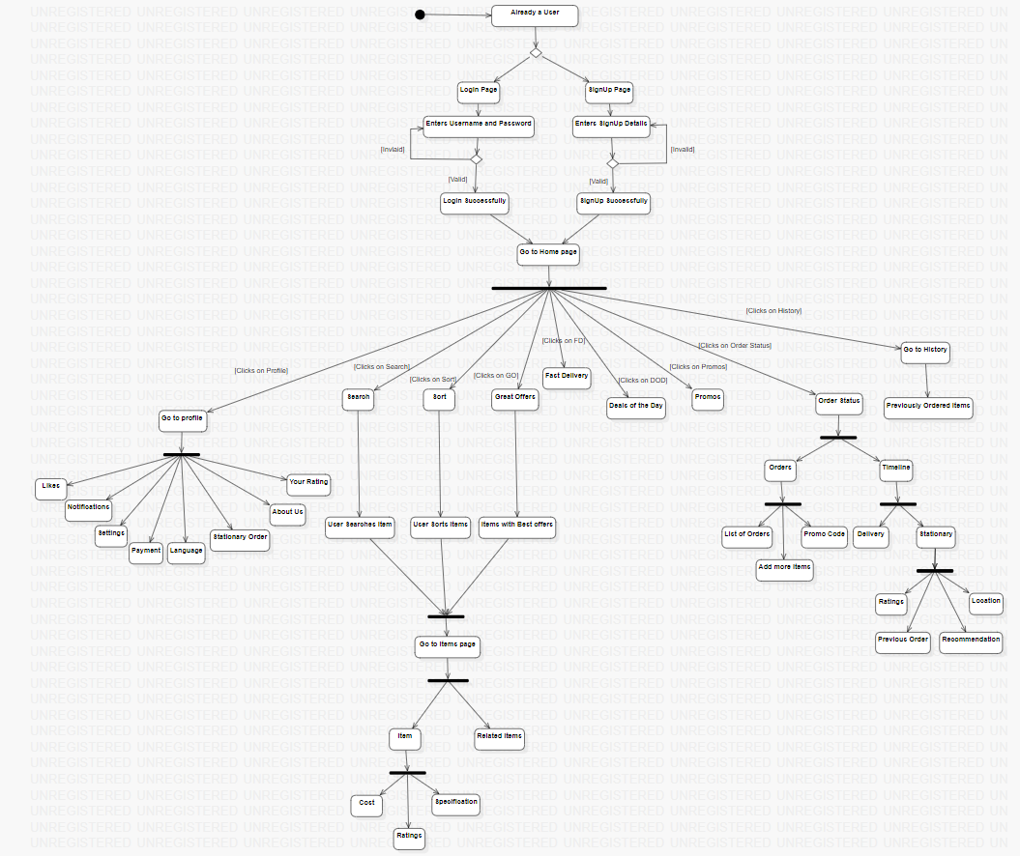

**Class Diagram**

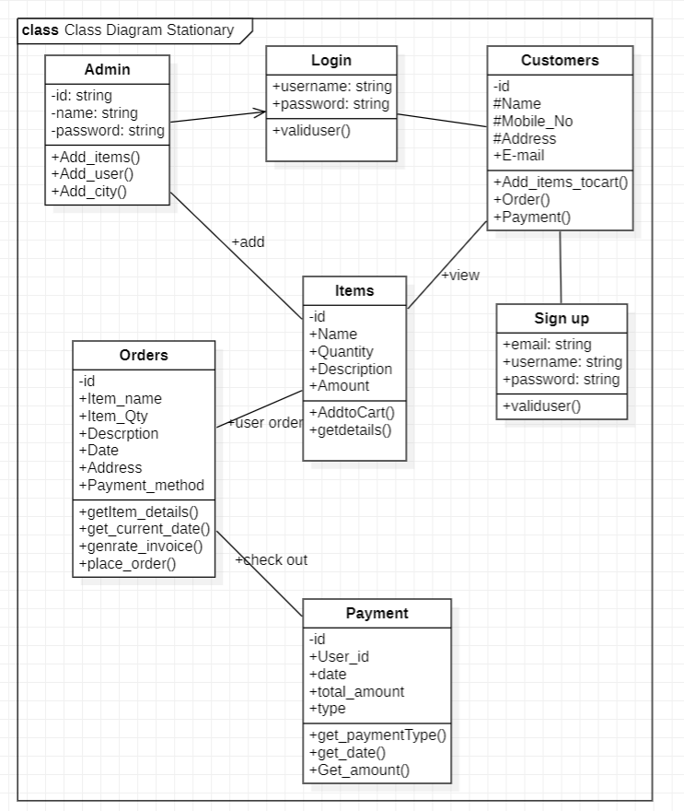

**Use case Diagram**

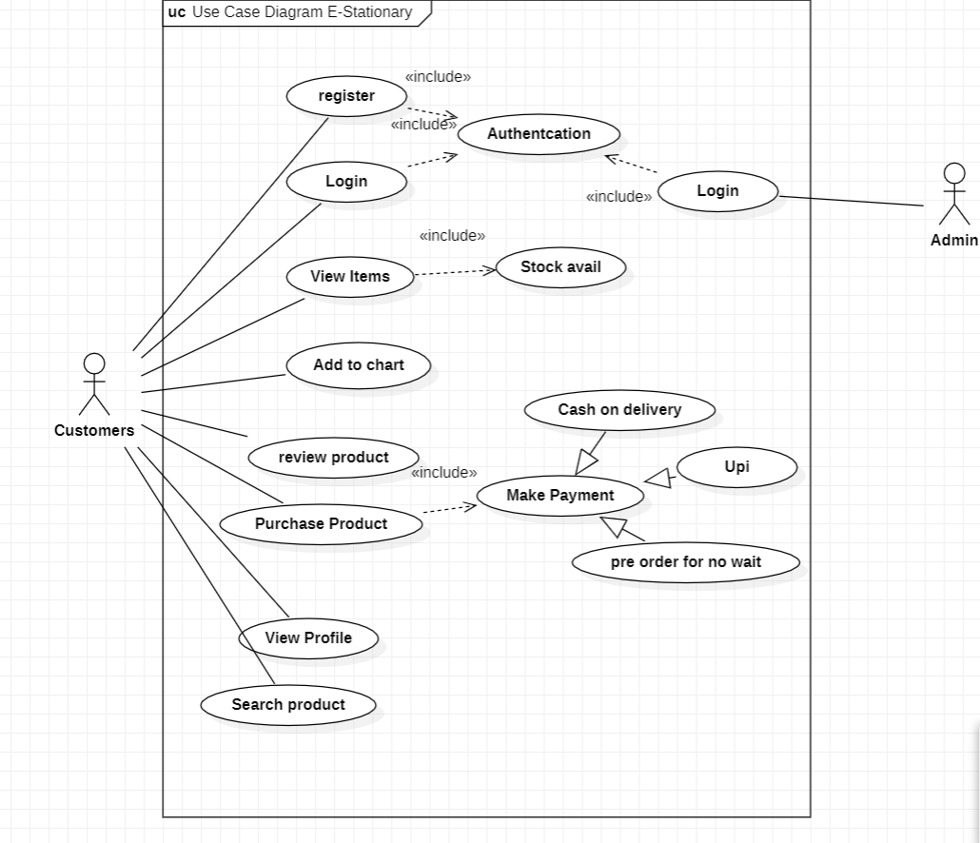

**Data Flow Diagram**

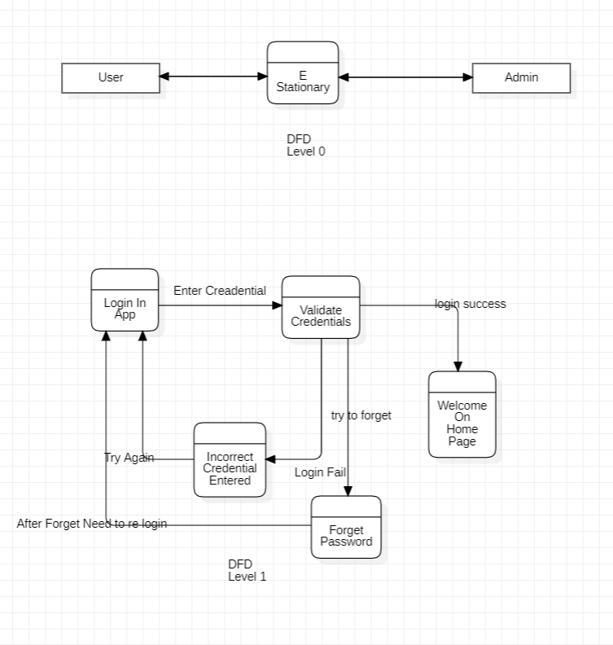

**Wireframes:**

